|  |  |
| --- | --- |
| **Ex No: 11** | **SIMULATION OF CLOUD SCENARIOS USING CLOUDSIM** |
| **Date: 30/05/22** |

**AIM:**

To implement the simulation of cloud scenario using cloudsim.

**PROCEDURE:**

1.Download Cloudsim 5.0 from [https://github.com/Cloudslab/cloudsim/releases/tag/5.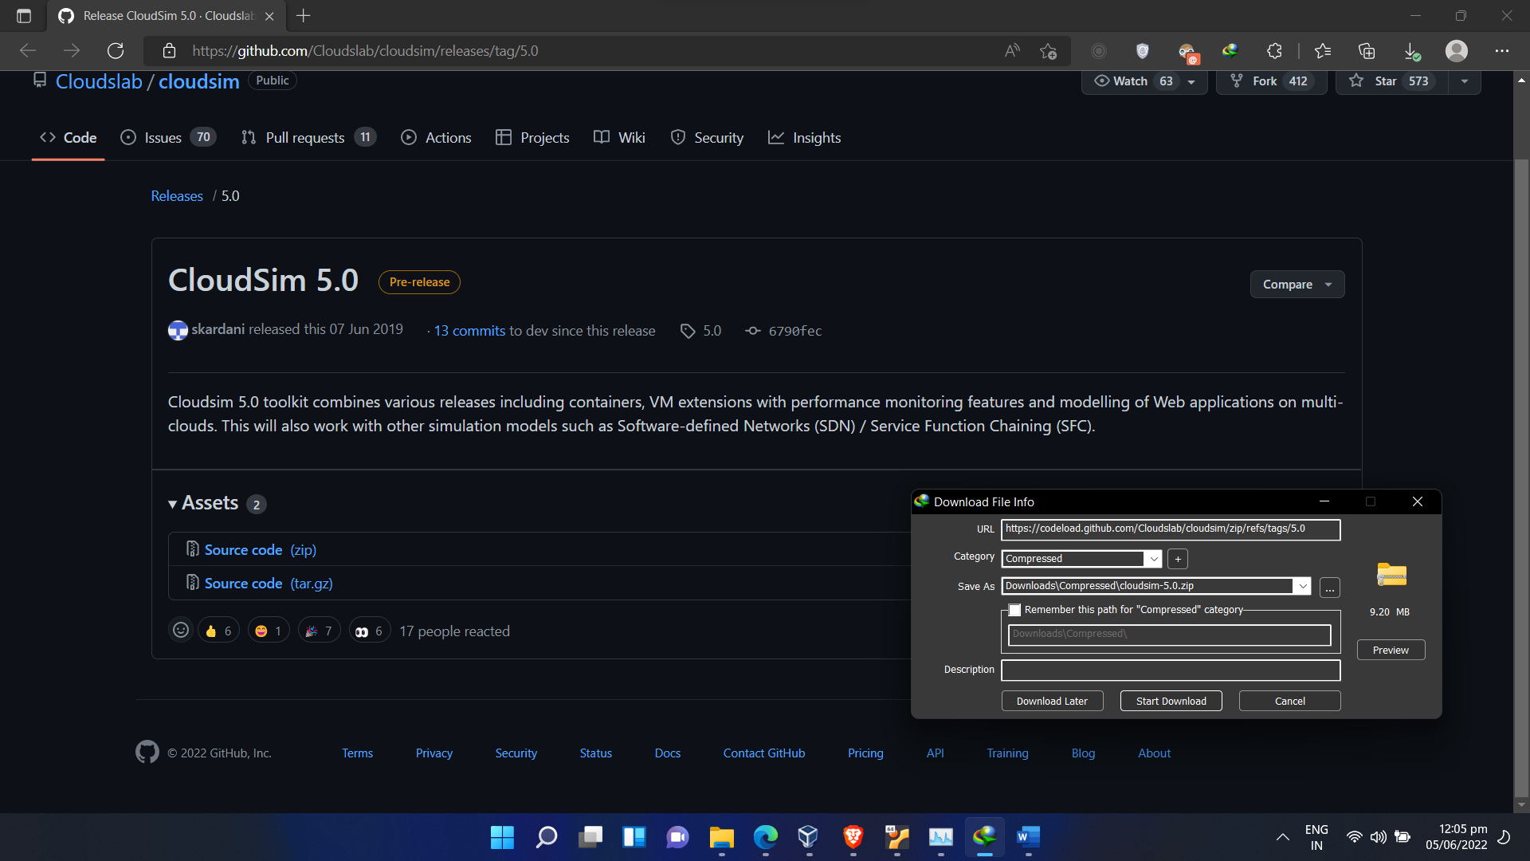](https://github.com/Cloudslab/cloudsim/releases/tag/5.)

2.Add common math library https://commons.apache.org/proper/commonsmath/download_math.cg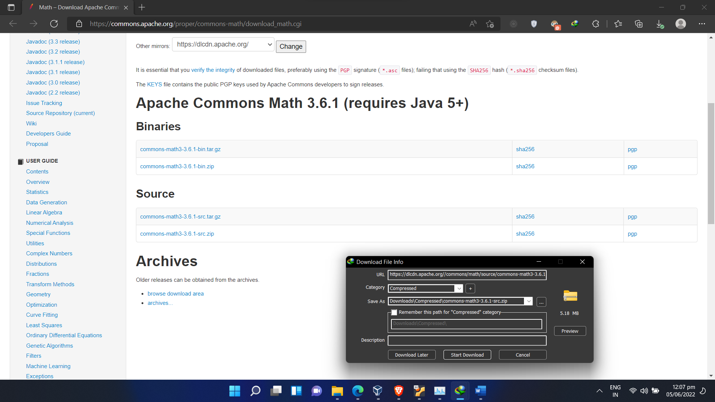3. Open Eclipse. Select New > Project > Java Project 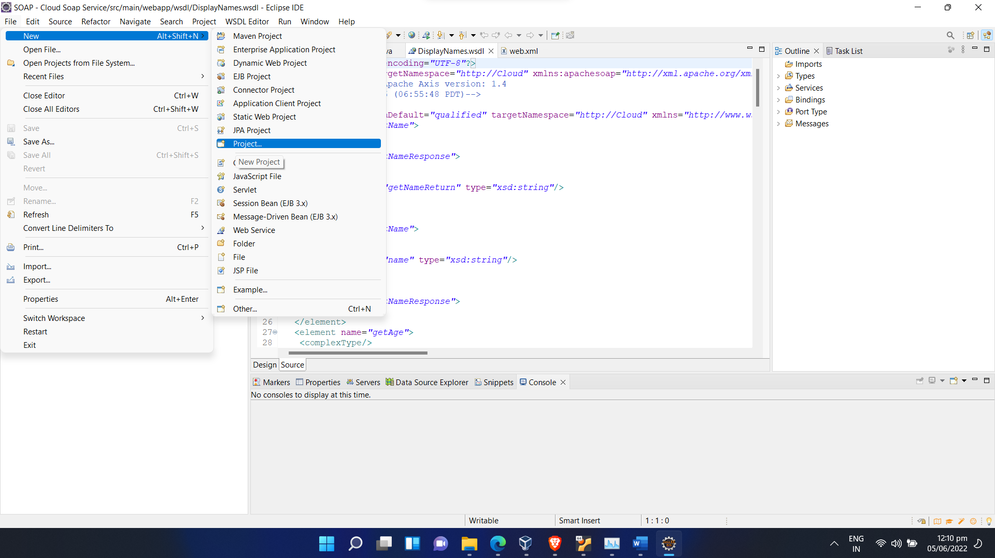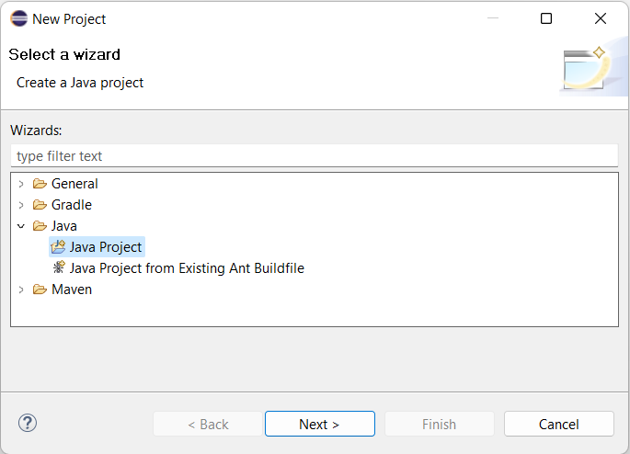

4. The project is named as Cloudsim and the location of the downloaded folder is specified. 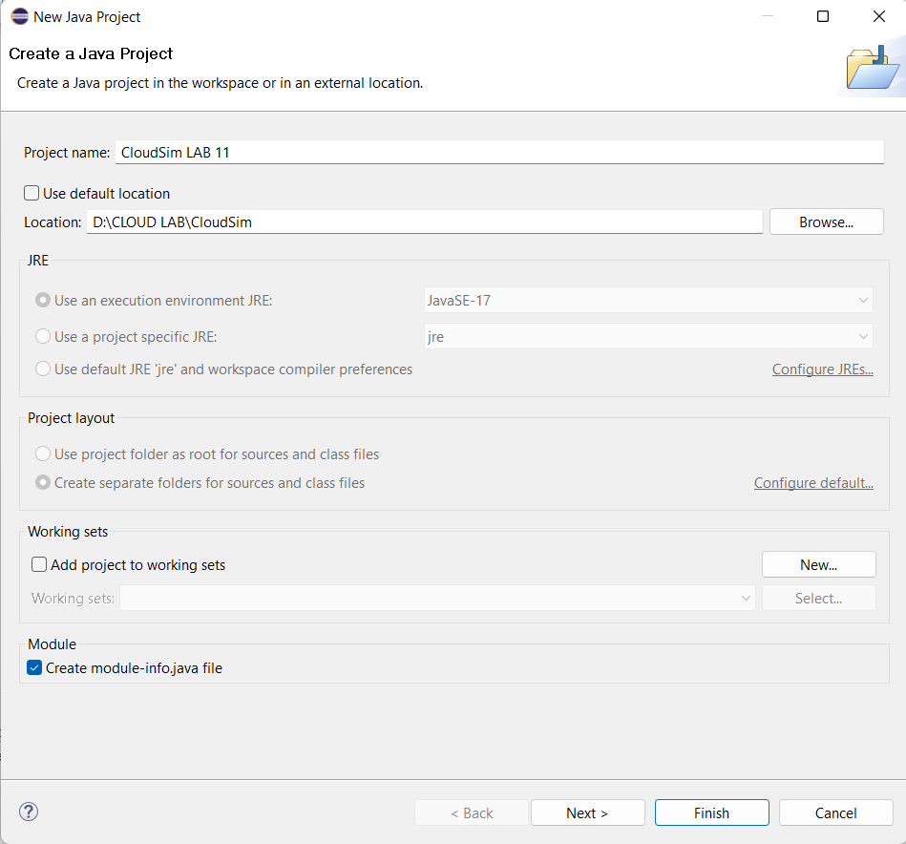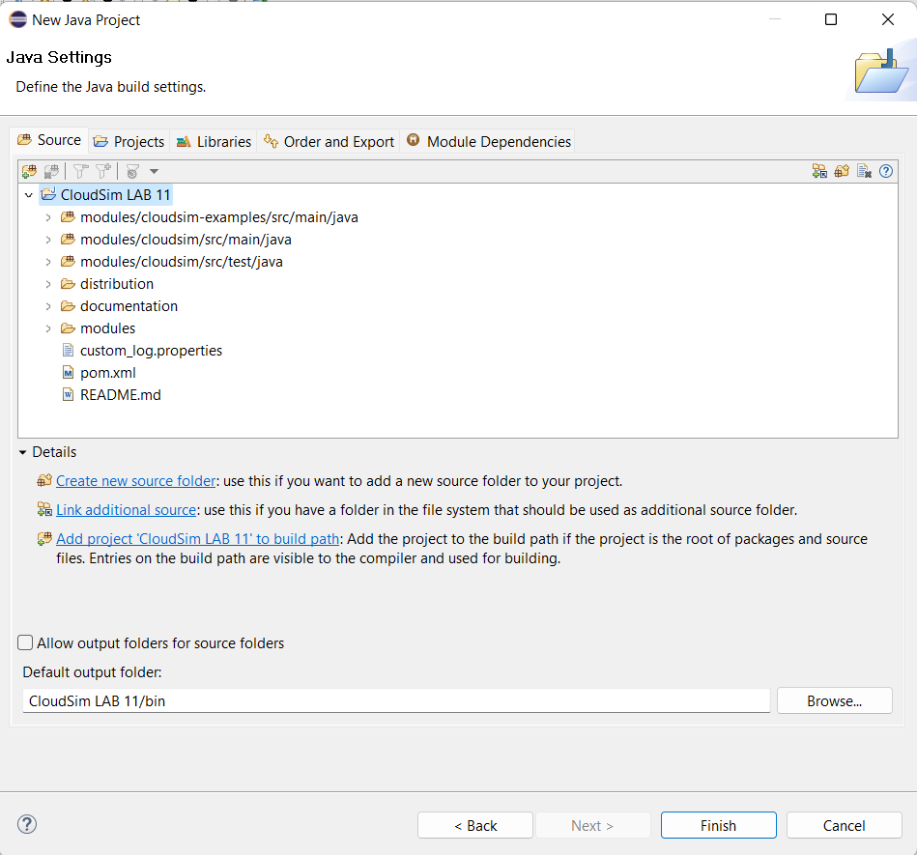

Once you click finish, the cloudsim project becomes viewable in your package explorer as shown below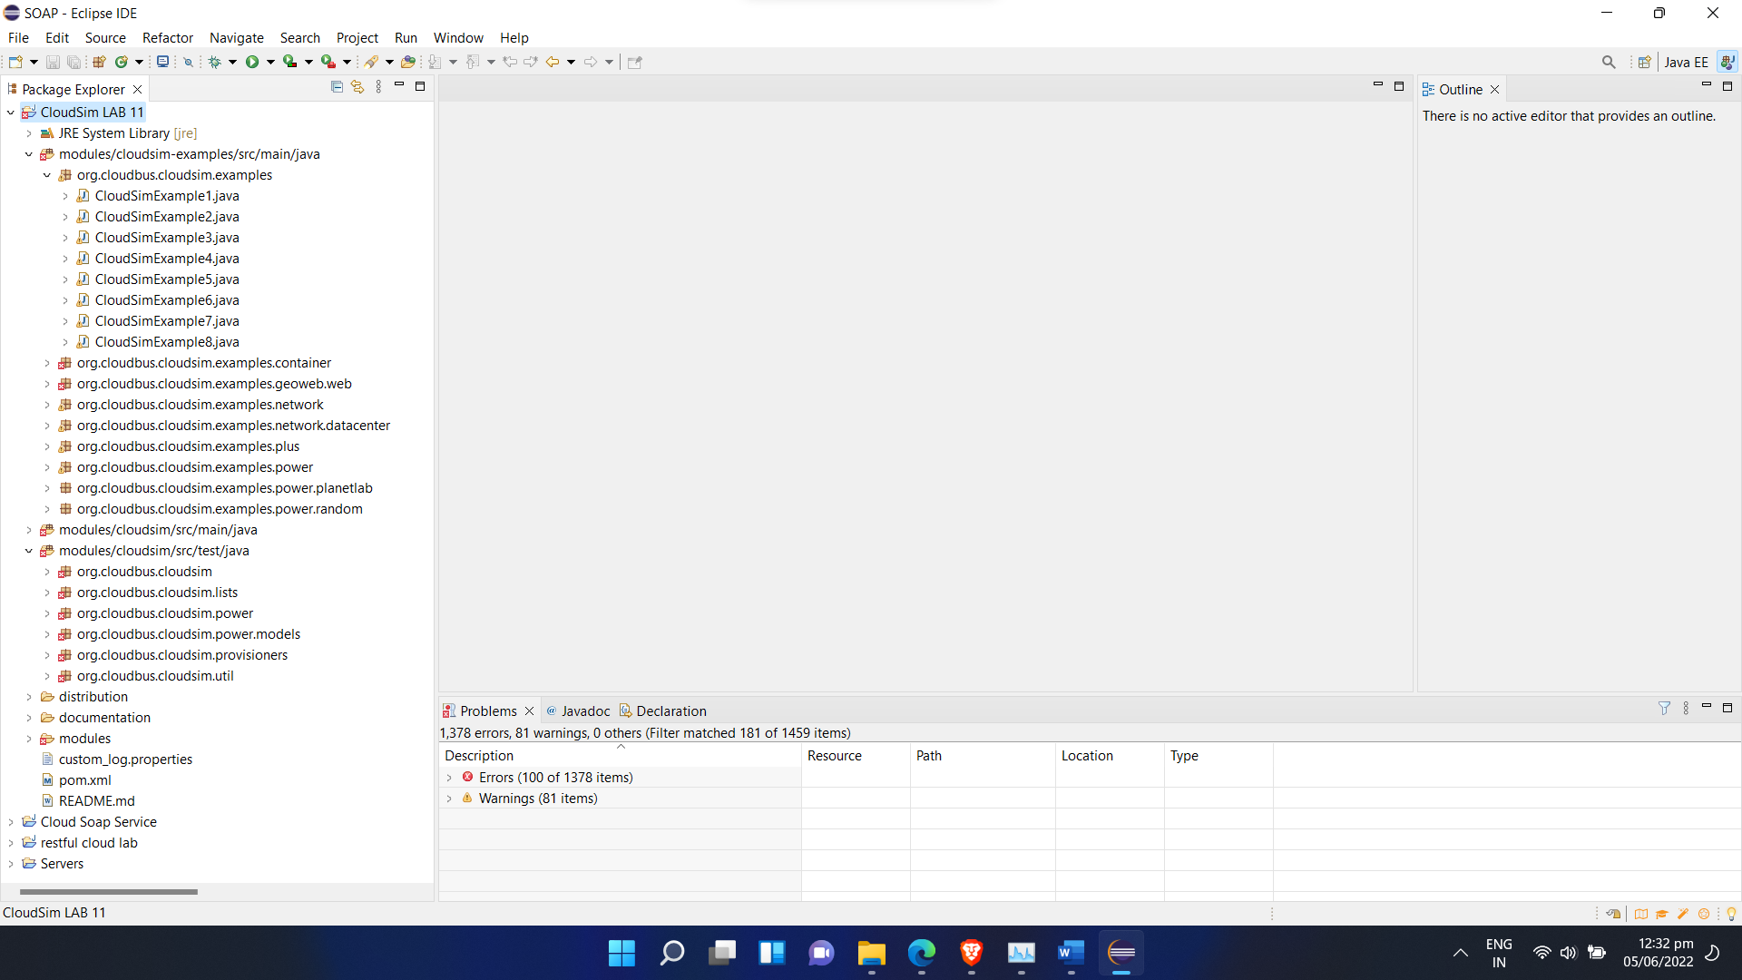

5. Click the created java project “Cloudsim” and select the properities. 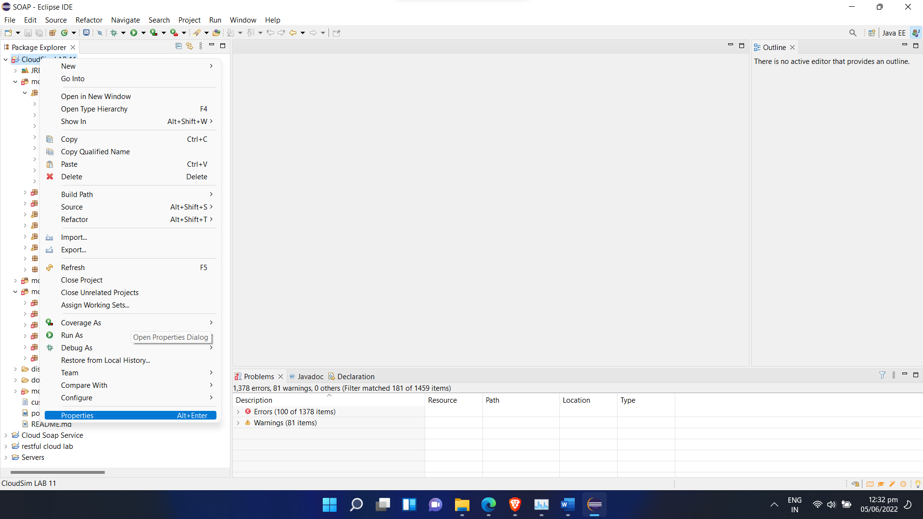6. Click Java Build Path and select Modulepath and add external JARs 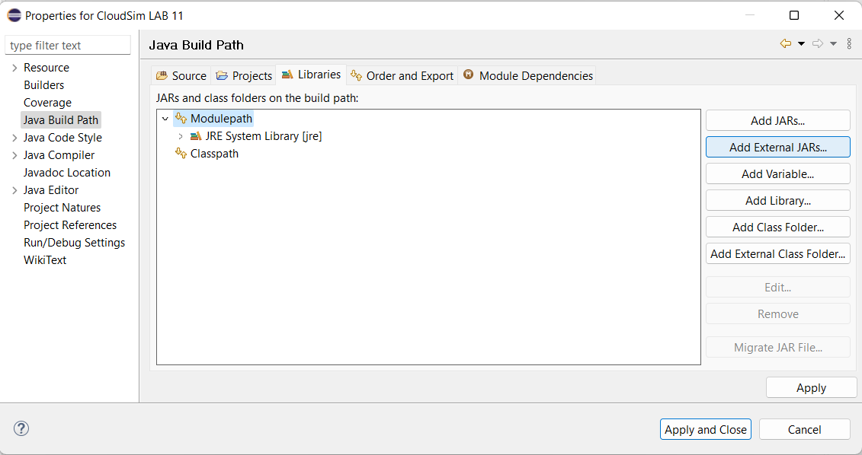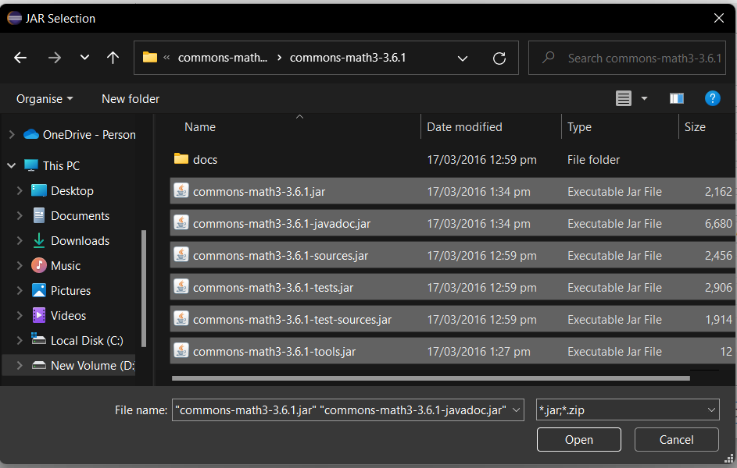

Hence, the installation is completed. To simulate the cloud services, the Cloudsim Example codes are executed

**Cloudsim example 1:**

An example showing how to create a datacenter with one host and run one

cloudlet on it.

**Description:**

1. Set the Number of users for the current simulation
2. The createDatacenter() method initializes the various datacenter
3. characteristics along with the host list.
4. The createBroker() method initializes the entity object from
5. DatacenterBroker class
6. Create a Virtual Machines and also create cloudlets.
7. Invoke method to start and stop stimulation.
8. Finally, print the final status of the Simulation.

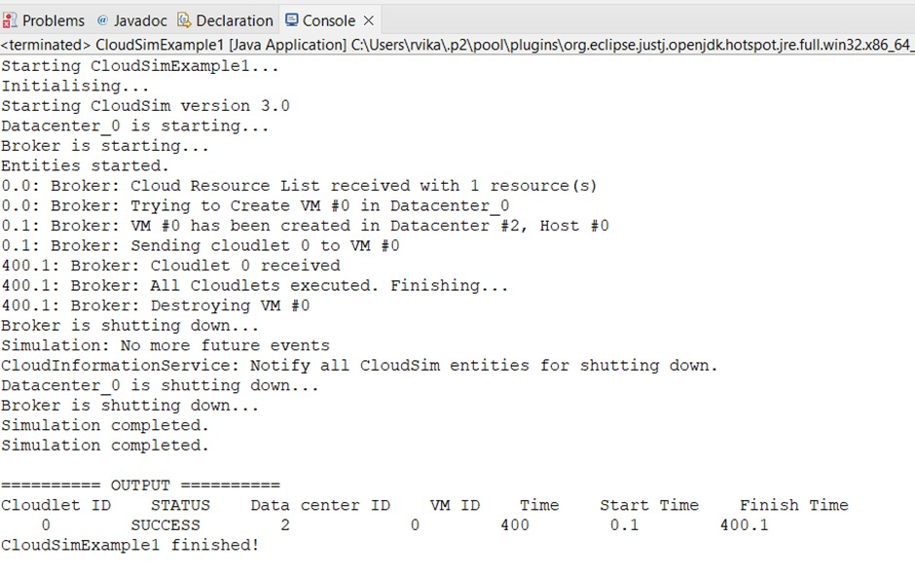

**Cloudsim example 6:**

An example showing how to create scalable simulations.It means varying

numbers of cloudlets as well as varying numbers of VMs.

**Description:**

1. Create VM, datacenters,cloudlets by its respective methods.
2. To create powerdatacenter we need to create a list to store one or more Machines. A Machine contains one or more PEs or CPUs/Cores. Therefore, should create a list to store these PEs before creating a Machine.
3. Create Hosts with its id and list of PEs and add them to the list of machines
4. Create a DatacenterCharacteristics object that stores the properties of a data center: architecture, OS, list of Machines, allocation policy: time- or space-shared, time zone and its price.
5. Finally prints the cloudlet objects

.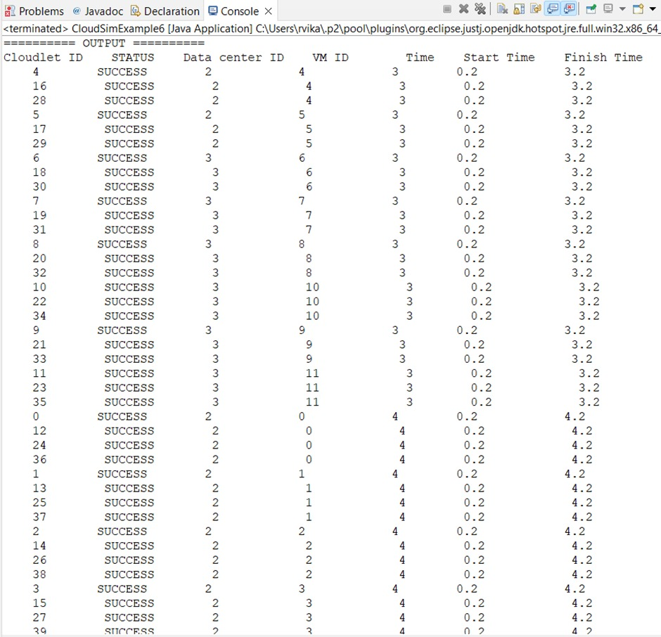

**RESULT:**

Hence the simulation of cloud scenario using cloudsim is verified